Object Two
Object One

Object Two
Object One

Object One
Object Two
--15 px--

Object One
Object Two

The Position Property
The position property is used to orientate elements on the page. There are five elements associated with the position property; absolute, fixed, relative, sticky, and static.
Static
This is the default element.
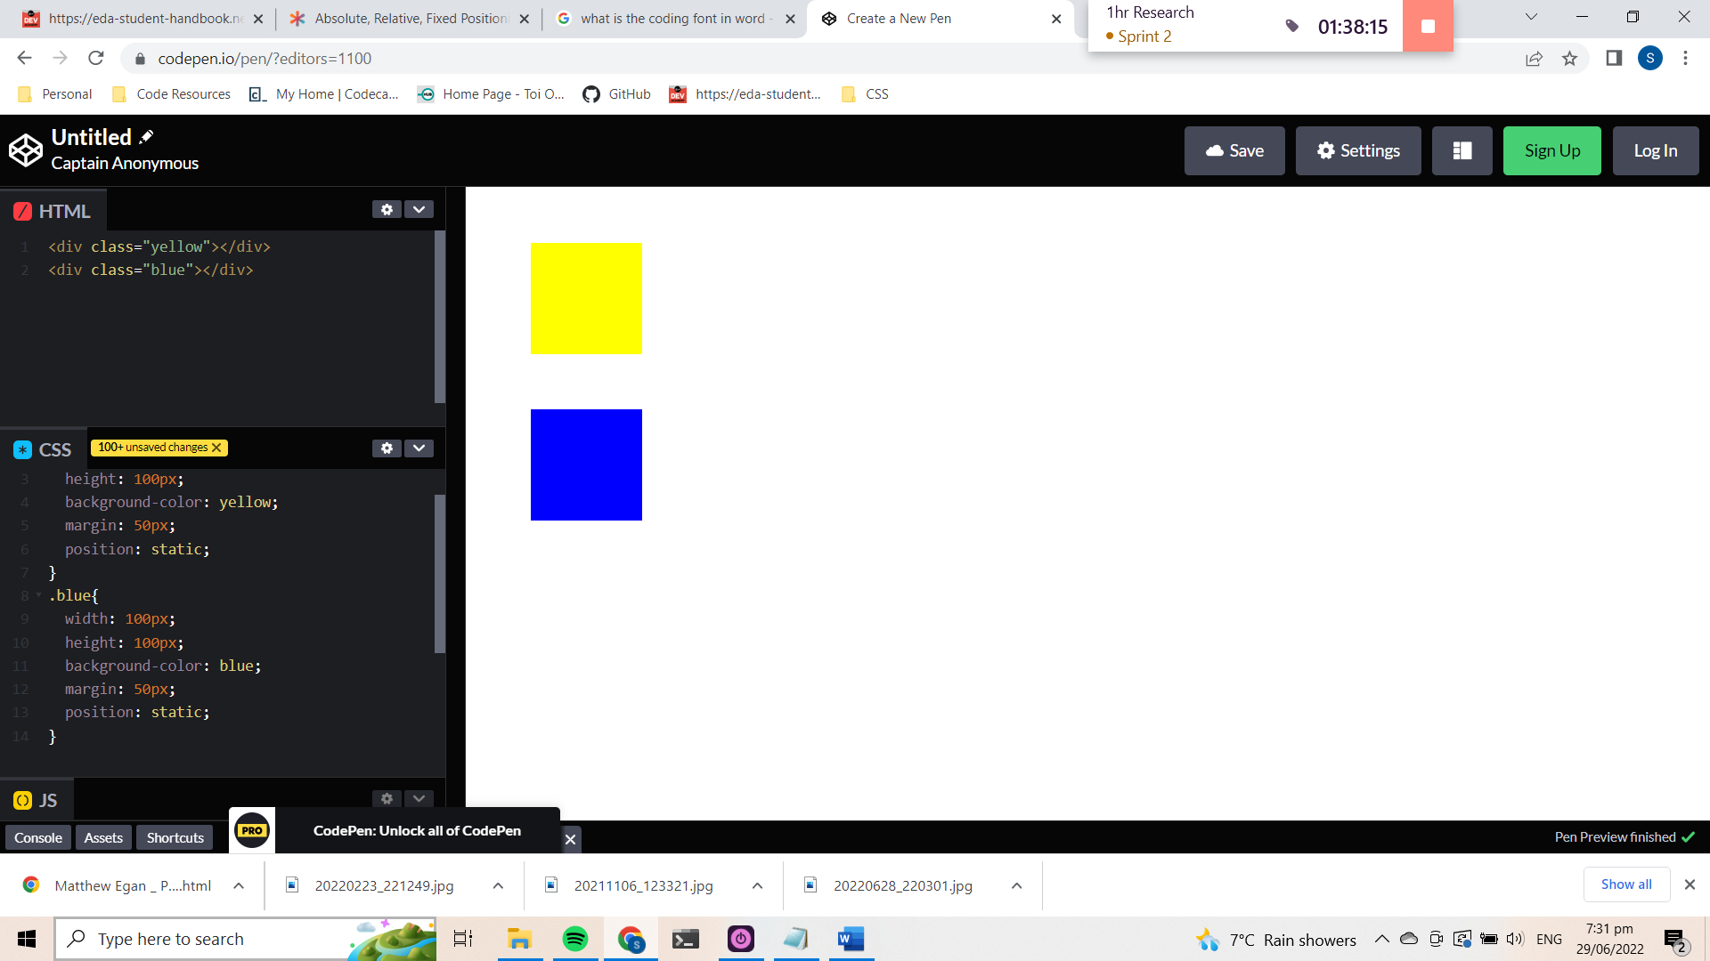
Relative
This means “relative to itself” and will only have an effect if a related attribute is applied to it. The related attributes are; top, left, bottom, and right. These attributes must have a value assigned to it (px, % etc). Once the attribute is applied the element will move in relation to its original position on the page. This can be very valuable for tweaking the exact alignment of an element without having to consider the overall relativity of the page.
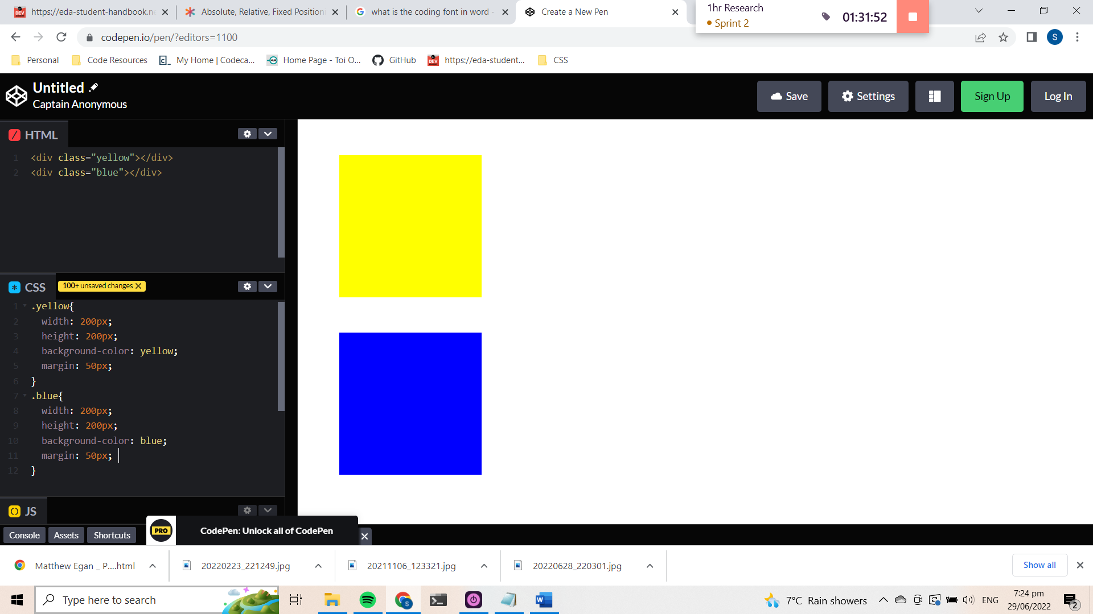


It works by adding the value to the given attribute direction. Eg. Setting a value to the left will cause the element to move to the right.

Object One {
position: relative;
left: 15px;
}

Relative positioned elements can however move over top of statically positioned elements, so it is something to be aware of.

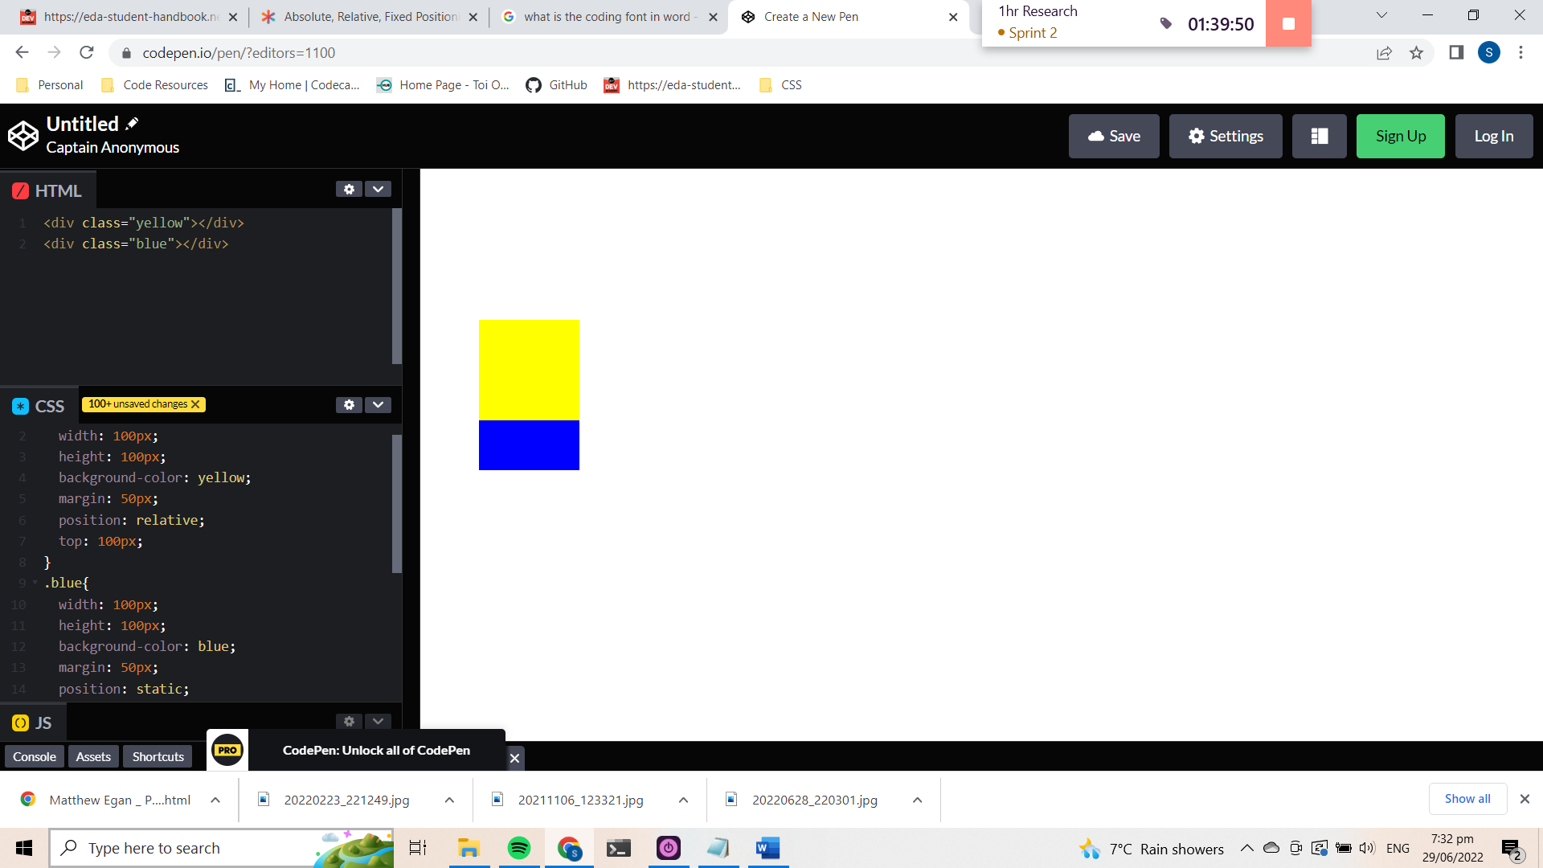

Absolute

Absolute positioned elements are relative to the next parent element that has relative or absolute positioning. If there aren’t any, they are relative to the to the html element. It also uses the positioning attributes top, bottom, left and right. Absolute positioning removes an element from being affected by other elements on the page.

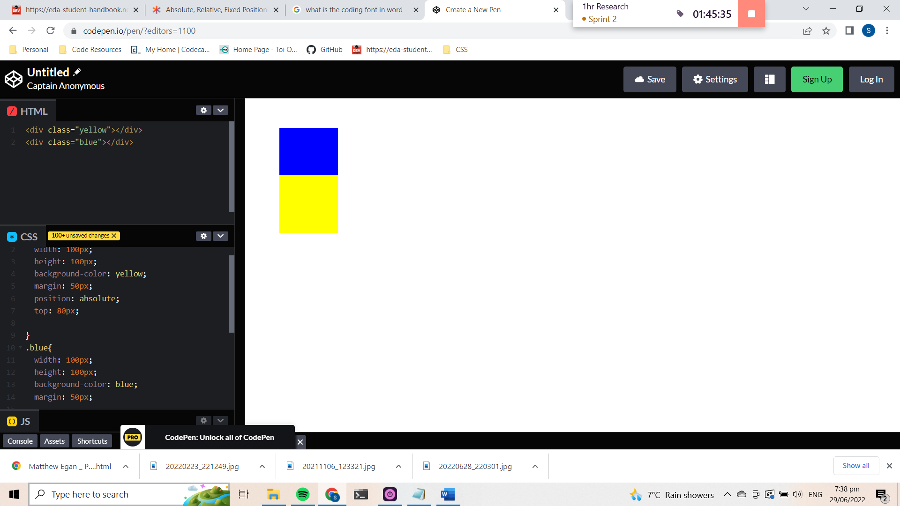

Fixed
A fixed position element is positioned relative to the viewport, or the browser window itself. The viewport doesn’t change when the window is scrolled, so a fixed positioned element will stay right where it is when the page is scrolled.
This might be used for something like a navigation bar that you want to remain visible at all times regardless of the pages scroll position. The concern with fixed positioning is that it can cause situations where the fixed element overlaps content such that is is inaccessible. The trick is having enough space to avoid that, and tricks like this.
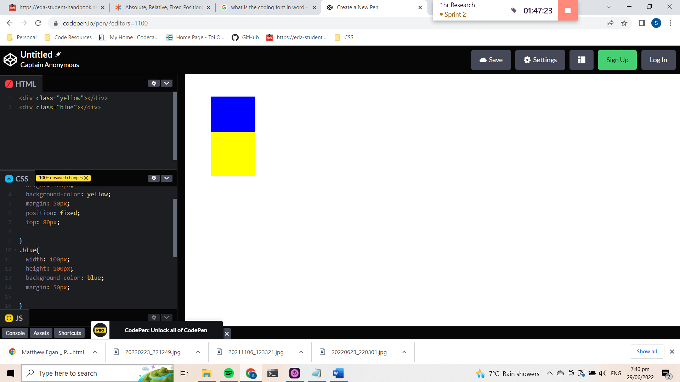

sticky
Sticky positioning is really unique! A sticky element will just sit there like a static element, but as you scroll past it, if it’s parent element has room (usually: extra height) the sticky element will behave as if it’s fixed until that parent element is out of room. It sounds weird in words like that, but it’s easy to see what’s happening in a demo.

Related Concepts
https://css-tricks.com/absolute-relative-fixed-positioining-how-do-they-differ/
https://codecrunch.org/css-position-23ad6d0cc5f9

